Step # | Description of Step | Tools, Materials, Parts and Process
 | This work instruction details the process to install the central locking componentry for the FO41 model canopy.  Here, detailed tooling and componentry requirements are outlined. | 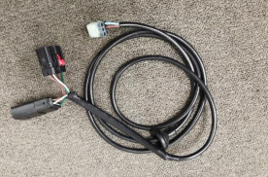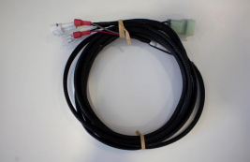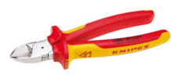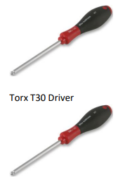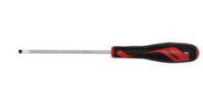  Central Locking Vehicle Loom – FO41  Code: C7B-LOOM-FO41  Central Locking Canopy Loom – Generic (included w/ canopy)  Code: C7B-LOOM-001  Side cutters  Torx T30 Driver  #2 Hex Key Driver  4mm Flat Screwdriver
 | First, remove the left-hand side brake light cluster by loosening and removing the two Torx screws.  To access the screws the tailgate must be lowered. The screws are located on the inside wall of the wellside.  Cut the cabletie securing the brake wiring to give more wire length to be able to lay the light on the tailgate.  Cover the light with a soft cloth or towel to protect the lens. | 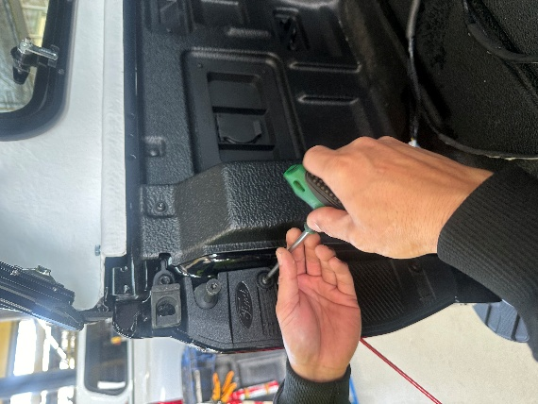 | 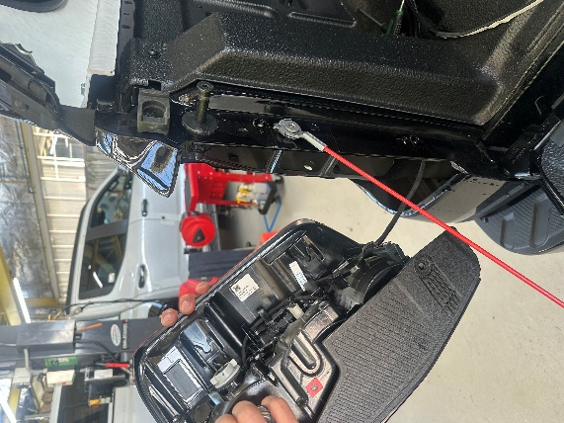
 | Locate the wiring loom from the canopy, C7B-LOOM-001. Remove the plastic plug by applying outward pressure to the metal pins.  Take great care to avoid damaging the pins as they are ejected. | 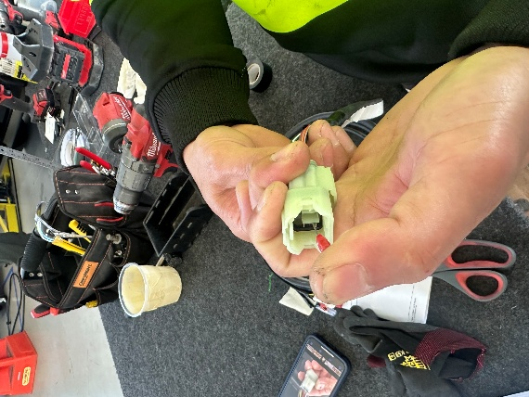
 | Feed the wire through the top of the wellside. There are pre-cut holes for this so no drilling is required. All excess length should be fed through to keep the tub clear of excess wiring. | 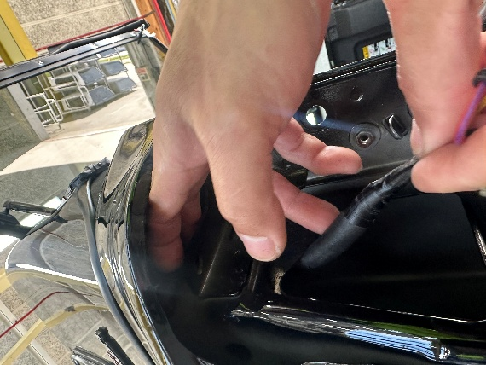 | 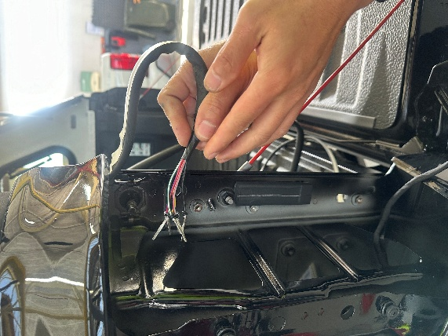
 | Reconnect the head of the plug to the wiring from the canopy. | 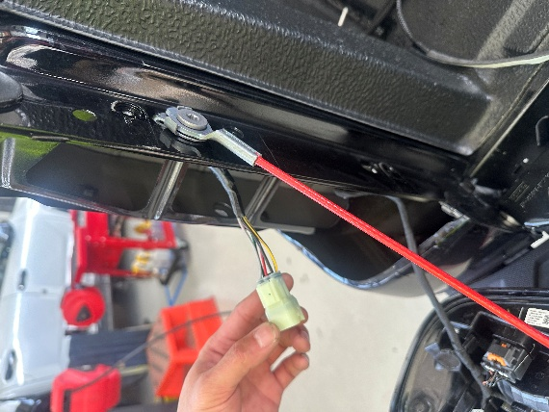
Locate and unpack the central locking patch loom, C7B-LOOM-FO41.

If the loom has a rubber boot, this was used for previous versions of installation. It can either be removed or stowed inside the vehicle body.
 | Locate the central locking connectors near the rear right wheel.  Note: this is a 16-way black plug.  Carefully disconnect this plug. | 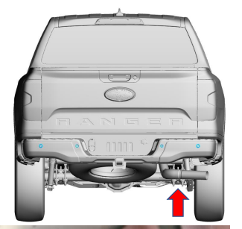 | 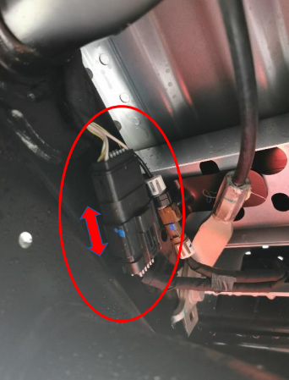
 | Patch in the central locking loom, C7B-LOOM-FO41. Cable tie these connectors to the vehicle harness nearby. | 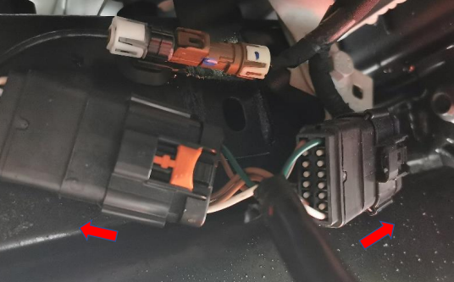
 | Run the patch loom and lid connector (6-way white plug) along the rear of the chassis to the left-hand rear taillight cable. Tie in the patch loom to the existing vehicle harness.  NOTE: It is critical this patch loom is kept clear of exhaust pipes and brake lines. | 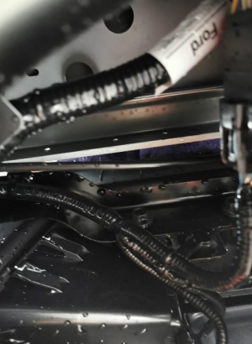 | 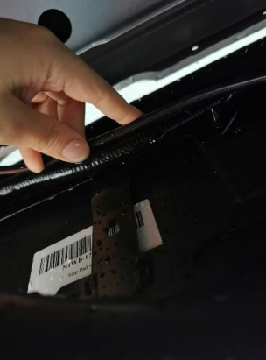
 |  | 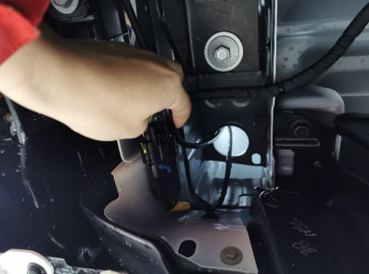 | 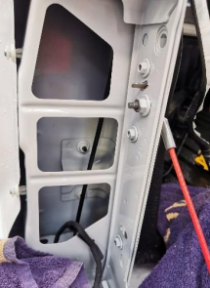
 | Connect the central locking loom, C7B-LOOM-FO41, the canopy generic loom, C7B-LOOM-001, which has been fed into the taillight housing.
Refit the taillight to the vehicle. Once refitted, test the lights after shutting all doors. Ensure the following functions are working correctly:

- Taillight (headlights on only)
- Brake light (push brake pedal)
- Reverse light
- Indicators
- Locking mechanism on canopy.
 | The process for wiring central locking for the FO41 is now complete.

